Advancing in English as a Second Language
All students who plan to study English as a Second Language (ESL) at PPCC will first complete a PPCC Application online at ppcc.edu/apply or will apply at Enrollment Services at the Centennial Campus (Room A110). They will then take the ESL Placement Test; go to Room F200 or call 502-3535 for more information. Finally, they will meet with an advisor to register for classes. Call 502-3535 for an appointment.
ESL students will meet with an ESL advisor each semester to help them register for classes. As seen below, we have three levels of study. Students must complete the three advanced level classes to receive a Certificate of Completion. After completing the ESL program, most of our students take the college placement exam and continue with regular classes at PPCC.
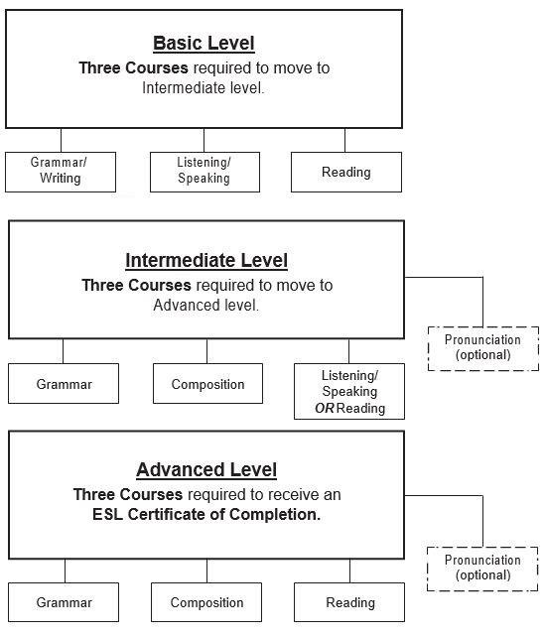

For ESL course descriptions, please visit the ESL Master Course Syllabi web page.

