Exporting D2L Gradebook and Attendance

- Log into https://mycourses.cccs.edu/d2l/home
- Select your course and go to your D2L gradebook.
- Select the “Export” button.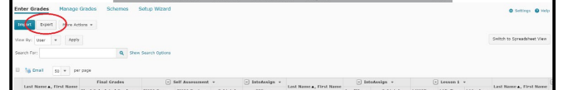
- Keep default settings, but be sure to select First Name and Last Name options
- Then select “Export to Excel”
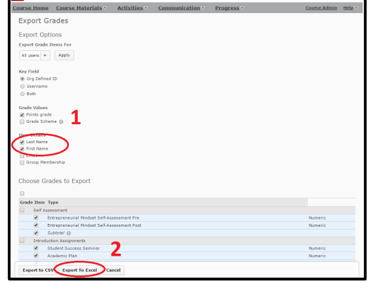
- Open the file link that appears on the export page – the file will open in Microsoft Excel:
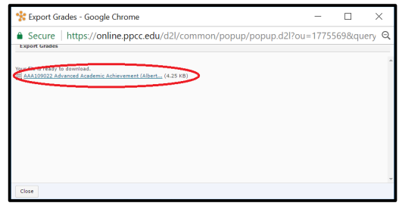

- After opening the file in Excel – Save (using “Save As”) and rename the file with your course information and your name. In ideal example is :
“ BUS 1015.101 – Gradebook – First Last Name”

- Be prepared to submit your gradebook along with your attendance book and grade submission to the D2L division shell.
Exporting your Attendance Record:
- Login to
- Select your course and go to your D2L attendance record.
- Select the “Export All Data” button.
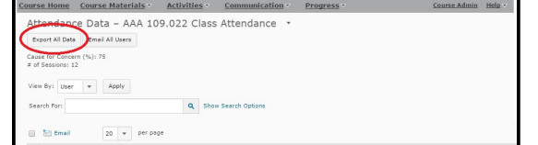
- Open the file link that appears on the export page – the file will open in Microsoft Excel:
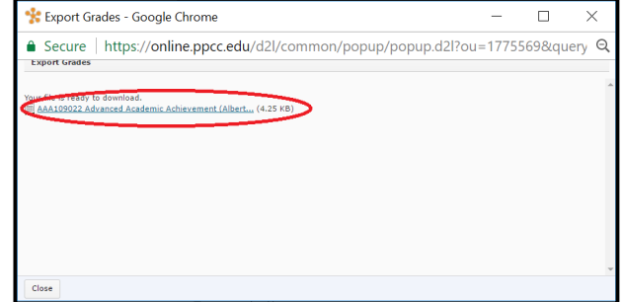
- After opening the file in Excel – Save (using “Save As”) and rename the file with your course information and your name. Be sure to change the file type you are saving to an Excel Workbook. An ideal example for naming the file is:
“BUS 1015.101 – Gradebook – First Last Name
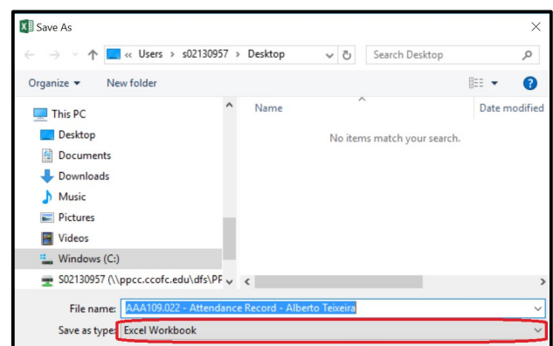
- Be prepared to submit your attendance book and grade submission to the D2L division shell.

