**Submitting your No-Shows into Banner (SSB) and D2L**

**Step 1: Entering No-Shows is a two-step process… your role is not finished until Both items are completed.**

1. **Login to** [**http://my.ppcc.edu**](http://my.ppcc.edu) **and continue to the portal.**
2. **Select the “Post Final Grades/No Shows” button on your dashboard.**

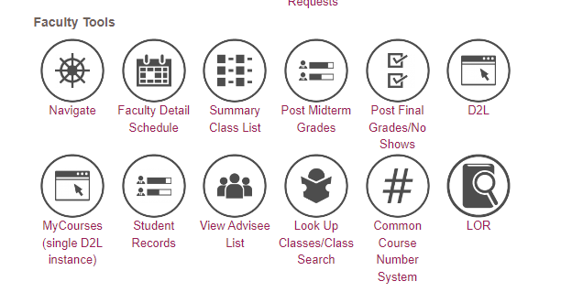

1. **On the next screen, select the current term – and press “Submit”.**

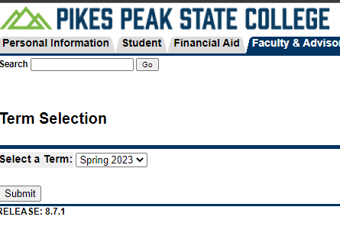

1. **Then select the course for which you intend to enter grades – and press “Submit”**

**FOR ENTERING NO-SHOWS**

1. **While on the final grades page, enter “0” (Zero) in the attended hours column next to students that are no-shows for your course. Leave all other entries blank.**

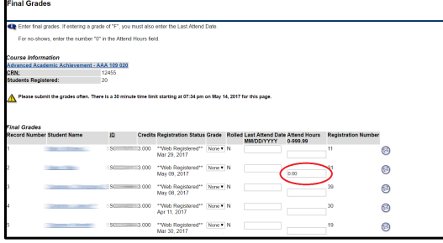

**Step 2: Submit Electronic copies to the BPS Division shell in D2L**

1. **While still on your final grades page, right click on the screen and select “Print” – or press Control (CTRL) and “P”.**

*Note: Depending on your web browser, the following screens might appear slightly different – but the fundamental steps are the same.

1. **After the print screen appears, select Change Printer:**
2. **Depending upon your internet browser (Chrome, Firefox, Internet Explorer), follow the below steps…**
3. **(if using the Google Chrome Browser) – Select “Adobe PDF” or “Save as PDF” or “Print to PDF”**

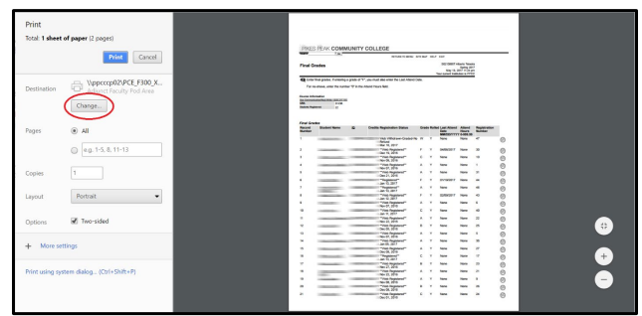

1. **(if using the Mozilla Firefox Browser) – Select “Adobe PDF” or “Save as PDF” or “Print to PDF”**

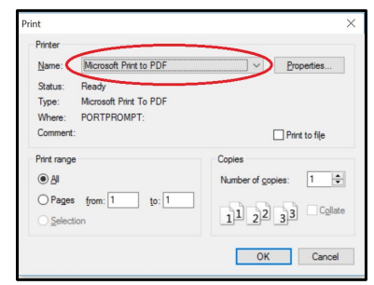

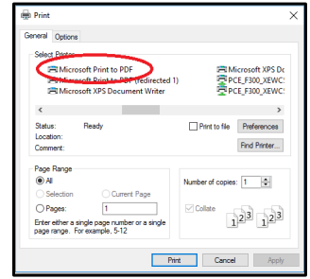

**C. (If using Internet Explorer) – Select “Adobe PDF” or “Save as PDF” or “Print to**

1. **A prompt will appear after selecting print that will ask you to select a location for your new PDF file.**
2. **Please name your file to include Your Course, Section, and Name. Save the file on yor computer in a location that is easy to find. The following example is ideal:**

**Ex: BUS 1015.101 – No Show Submission – First Last Name**

**Continue to the next page for instructions on how to post No-Shows to the BPS Division shell.**

1. **Log into D2L and select the division BPS Shell from your home screen, the current BPS division Shell is named “BPS Division (current year)”**

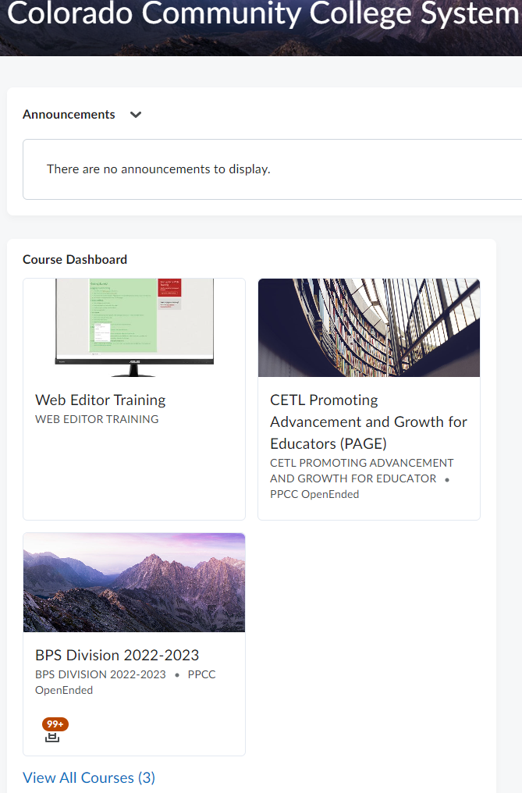

1. **Select the “Assignments” tab.**

**8.Select the appropriate submission folder for the No-Shows you are submitting:**

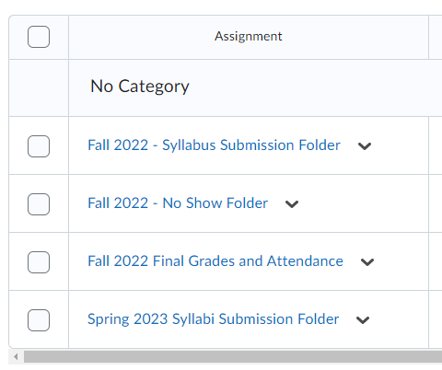

**9.Add required files by selecting “Add a File”**

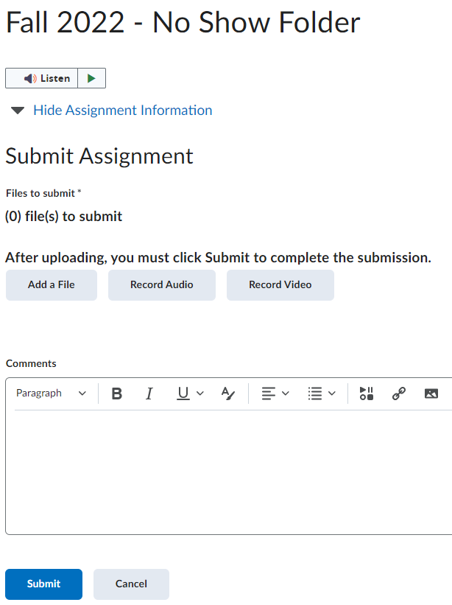

1. **Select “My Computer” and “Upload” to select your files.**

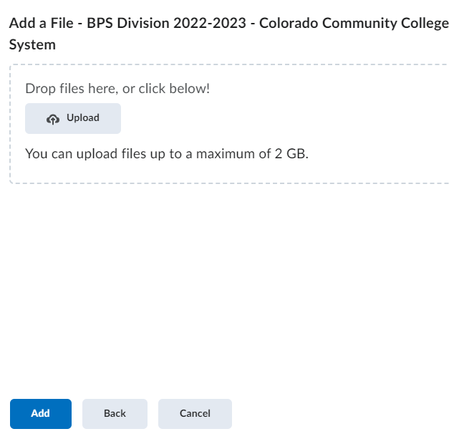

1. **Select your No-Show Submission files – and then select “Open”.**

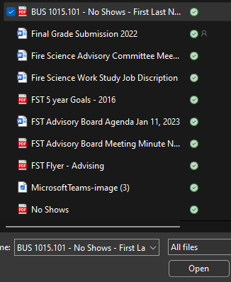

1. 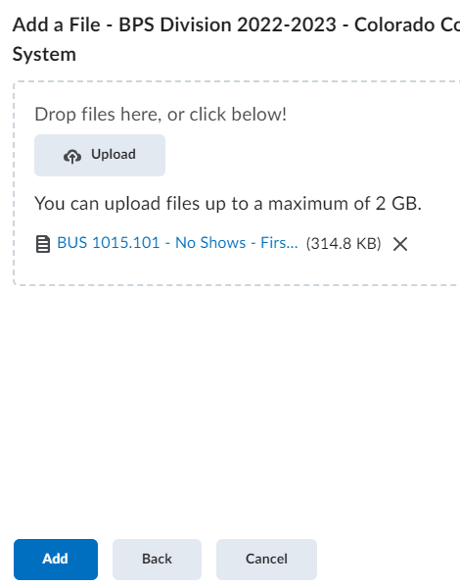**Ensure that all of your submission files are uploaded and select “Add”.**
2. **Add a comment on your submission screen with your: course and section information, and your name.**
3. **After confirming that your files have been uploaded and comments completed, select “Submit”.**

