Submitting your Syllabus in D2L

- Log into D2L and select the division BPS Shell from your home screen. Choose the current years shell.
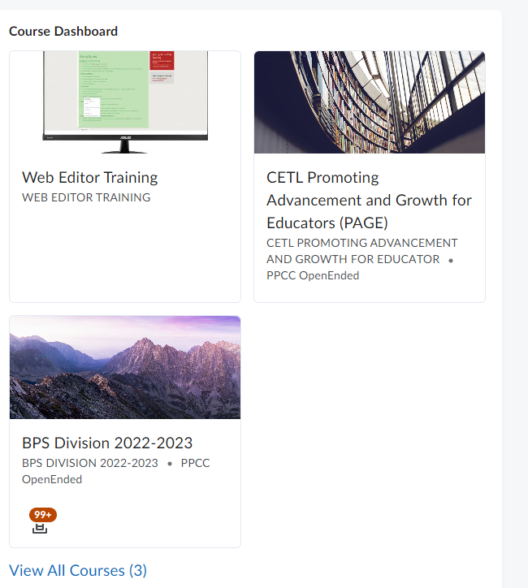
- Select the “Assignments” tab
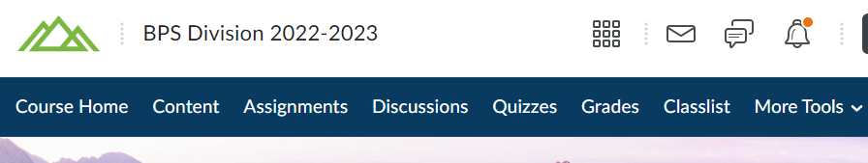
- Select the appropriate submission folder for the syllabus you are submitting:
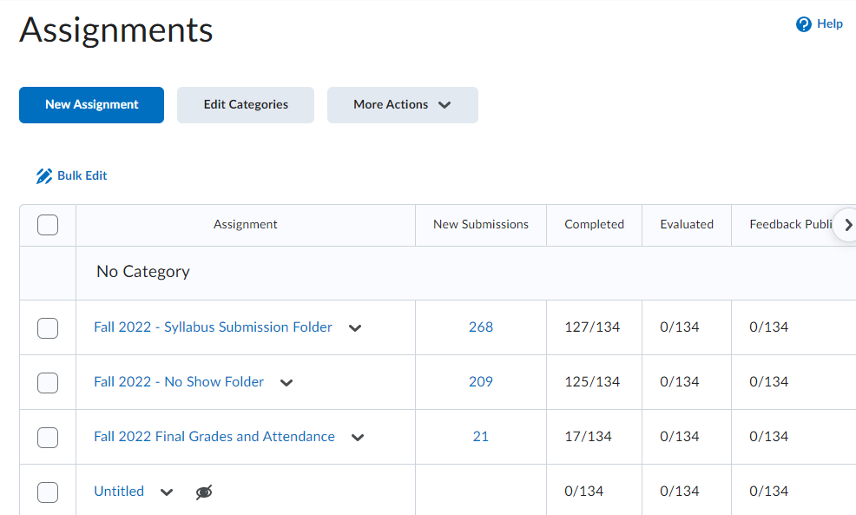

- Add required files by selecting “Add a File”
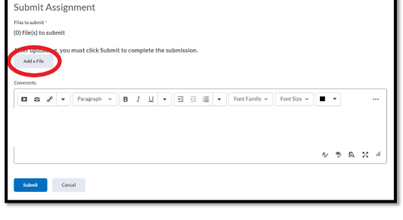
- Select “My Computer” and “Upload” to select your files.
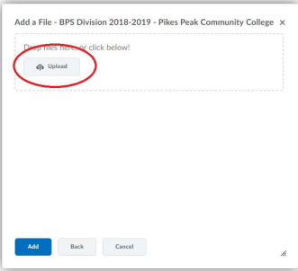
- Select your Syllabus Submission Files – and then Select “Open”
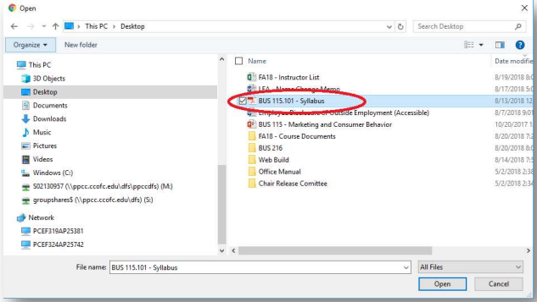

- Ensure that all your submission files are uploaded and select “Add”
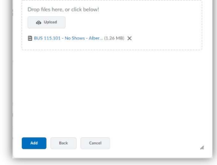
- Add a comment on your submission screen with your: course and section information, and your name.
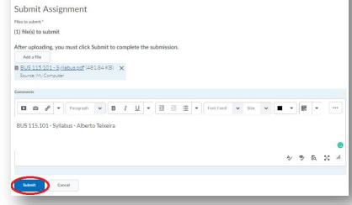
- After confirming that your files have been uploaded and comments completed, select “submit”.

