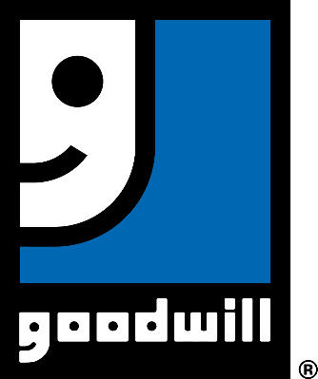**Position Title:**

**Marketing Intern – Unpaid**

**CONTACT PERSON:**

**Grace Vigil, Volunteer Services Manager**

**gvigil@DiscoverMyGoodwill.org**

**719.635.4483 (ext. 1229)**

**Position Overview:**

Goodwill is looking for an awesome marketing intern! We would like your assistance with graphic design tasks: create event signage, handouts, postcards, event programs and other marketing collateral under oversight of our in-house Graphic Designer and assist with website maintenance/updates.

**Title: Marketing Intern**

**Key Responsibilities:**

1. Graphic Design: designing signage, event materials, brochures, flyers, posters

2. Website Updates

3. Social Media Content Support (on an as-requested basis by our in-house team

member)

4. On-site, day-of event support: helping to provide customer delight to our guests

**Initial Impact:**

Increases impact by expanding capacity and therefore enhancing mission impact and helping build awareness of Goodwill’s mission: helping individuals achieve greater independence.

**Sustained Outcomes:** Expanding our team’s portfolio of marketing collateral, impacting our mission in a positive way.

**Training:**

On-boarding to learn about Goodwill’s team, culture and workflow. Ongoing training including specific feedback on assignments

**Support:** Feedback on specific assignments, being part of one of Goodwill’s most cohesive and collaborative teams, creative environment.

**Commitment:**

Length of Time: February through August 2020, negotiable

Amount of Time: 16 - 20 hours plus a week, negotiable.

Specify Evenings, Weekdays, Weekends: Normal business hours (8am – 5pm M-F with occasional evenings or weekends for events), negotiable based on weekly total hour commitment.

**Location of Volunteer Assignment:** 1460 Garden of the Gods Road, Colorado Springs

**Education:** Undergraduate in progress, or higher education: Graphic Design, Website Development, Marketing/Communication.

**Qualifications:** customer delight, solution-oriented approach to work, innovation, creativity, communication, collaboration.

**Skills:** Proficiency in InDesign, HTML, digital marketing (social media account management experience rather than as a consumer/user)

**Benefits:**

Gain real-world experience as a Marketing Intern for one of Colorado’s largest nonprofit organizations. Know that your contributions make a meaningful impact in the lives of those we serve: individuals with physical or intellectual disabilities, seniors, and people with economic challenges or barriers to employment.

Excellent resume-builder, hone InDesign and HTML skillset, learn how to be a key contributing member of a dynamic team in a fast-paced environment, working on multiple projects simultaneously.

**MISSION STATEMENT:**

Discover Goodwill is dedicated to helping people reach their highest level of personal and economic independence.