# Program Format for the PPSC Catalog

Programs refer to degree and certificates.

Before choosing a program name:

* Check with the PPSC Accreditation Liaison Officer (ALO) to make sure the Classification of Instructional Programs (CIP) program name and CIP Code you are working with is correct before submitting any programs. Reference the Curriculum Committee webpage for the PPSC ALO contact information.

Catalog Entry Information

1. Begin with any recommended basic skill courses, as in the example below. See black arrow in Figure 1. If these do not relate to your program, begin with 2. Program Description.

Figure 1: Recommended Basic Skills

Psychology, AA with Designation
College Readiness in English.
College Readiness for Quantitative Literacy for MAT 1240 or MAT 1260.
College Readiness for Algebra for MAT 1340.

1. The description should describe the program to students. Only include what applies from the list below. There is a program description example below the list.
   1. What will students learn
   2. What the program prepares students for, such as a specific profession or transfer opportunity
   3. Special program requirements such background checks, age requirements, minimum grade requirements
   4. Any required internships
   5. Any abnormal transfer agreements
   6. Certifications the students may be prepared to take after completing the program

Figure 2: Description Example

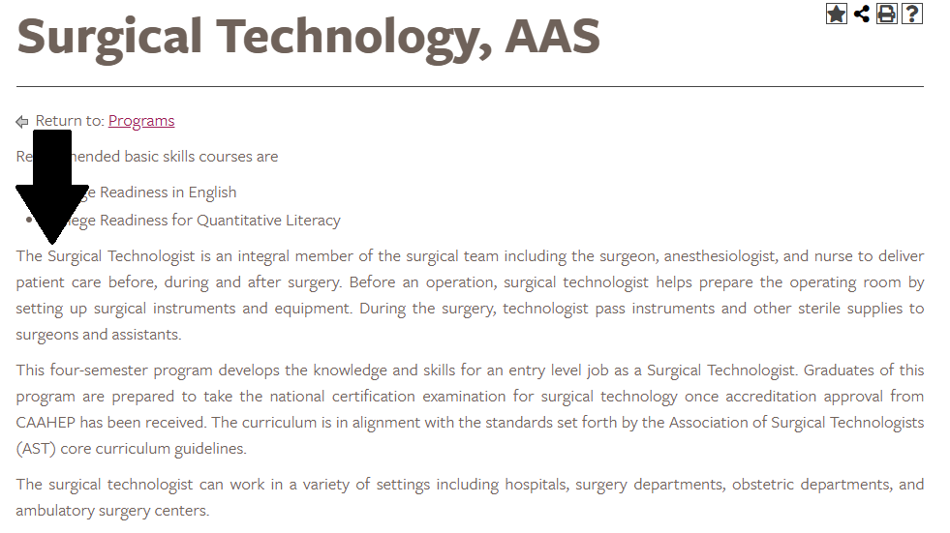

1. Next list the Program Learning Outcomes (PLOs)

“Upon completion of the XXX program/certificate, student should be able to:”

Guidance on PLOs:

* 1. For certificates, 2-5 PLOs are suggested
  2. For 60 credit programs, 5-8 PLOs are suggested
  3. PLOs must use Bloom’s verbs
     1. Use a single verb per PLO, unless verbs go together such as compare and contrast
     2. Use measurable verbs, avoiding fuzzy verbs like demonstrate understanding or recognize
     3. Support documents are available on the Curriculum Committee webpage including: Bloom’s verbs, PLOs for Certificates, Assessment PLOs
  4. Use the CCNS generated Course Learning Outcomes (CLOs) for the required classes in the program to develop the PLOs. Upper-level course CLOs (2000 level courses) are best to use, as student will be nearing program completion.
  5. PLOs in the catalog must be the same PLOs used for assessment and Program Reviews
  6. Contact your discipline’s Assessment Coach for help. They can be found on the Curriculum Committee webpage.

See below for an example of PLOs for a certificate program.

Figure 3: Program Learning Outcomes Example

Culinary Arts Certificate 
Program Learning Outcomes include 5 PLOs with verbs: create, prepare, plan, and apply.

1. Next, list the required and suggested courses for the program. For certificates, simply list the courses and total credit hours. For degrees use the following format.
   1. Start with General Education Courses, if applicable
   2. Follow up with Additional Required Courses
   3. Provide the required number of credits for each section.
   4. End with Total Credit Hours
   5. If applicable, under the total hours add a targeted Elective list.
      1. Do not use the entire AA or AS approved elective list. Pasting in the entire elective list requires that you change your program catalog entry every time a course on that list is retired.
      2. Notice in the example below that students are linked out to the entire electives list, but only 8 are listed as recommended. This practice is advised over pasting in a larger list of courses. You may also simply link out to the electives list without any mention of specific recommended electives.

­­­­­­­

Figure 4 (in 3 parts): Program Course Requirements Example

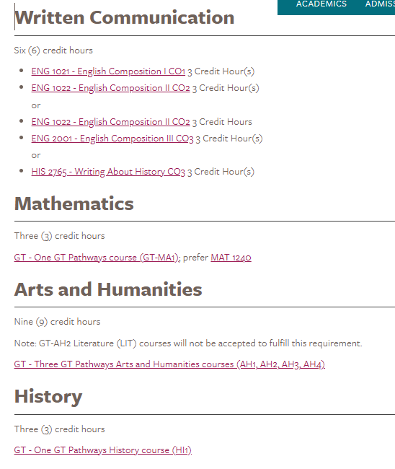Continued….

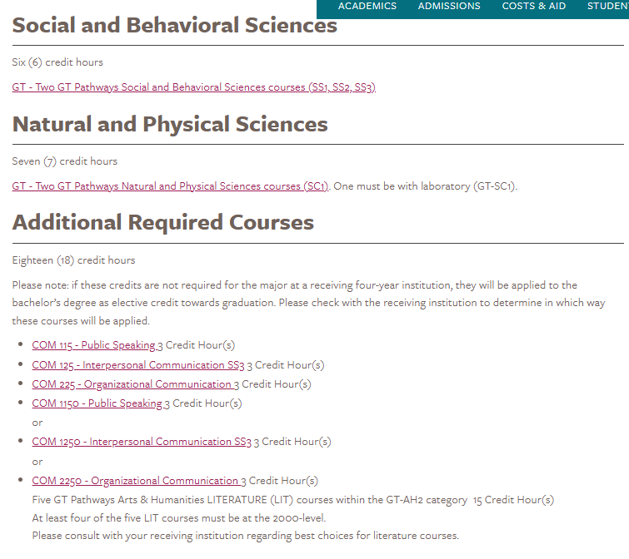Continued…

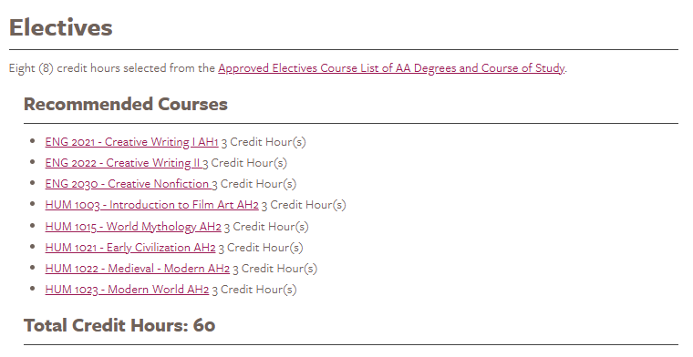

1. A hotlink on the program page of the catalog will direct readers to the program webpage where more information about the program can be conveyed. “Additional information available on the XXX Department website.”

Figure 5: Hotlink to Department Website Example

