Commencement Regalia Purchasing Guide Academic Year 2025-2026

Table of Contents

Introduction | 1
How to Order | 1
Timeline | 2
Choosing your Package | 2
Size Guide | 6
Cords, Stoles and Medallions | 7
Links and Resources | 7

Introduction
Congratulations on completing your program! We are so excited to celebrate with you at the Commencement Ceremony taking place at 10:30am at the Broadmoor World Arena on May 16, 2026. This guide is intended to give you everything you need to know about purchasing your regalia (aka cap, gown and tassel) including how to order, ordering timelines, which package to choose, a size guide, additional information on regalia accessories and more.

How to Order
Online
It is highly recommended that you order your regalia online. Doing so helps ensure that you get the right size and package and allows for time to correct any potential issues that could arise. You can order online at https://oakhallcg.com/pages/pikespeak.
Online orders will arrive at the Centennial or Rampart Campus Bookstores based on your preference and be available for pickup starting the week of April 13, 2026. You will be notified via email when your regalia has arrived.

In-person
If you miss the online ordering window, you may purchase regalia at the Centennial Campus Bookstore. Contact them directly with any questions as supplies may be limited. You can reach the bookstore directly at 719.502.2665.

Timeline
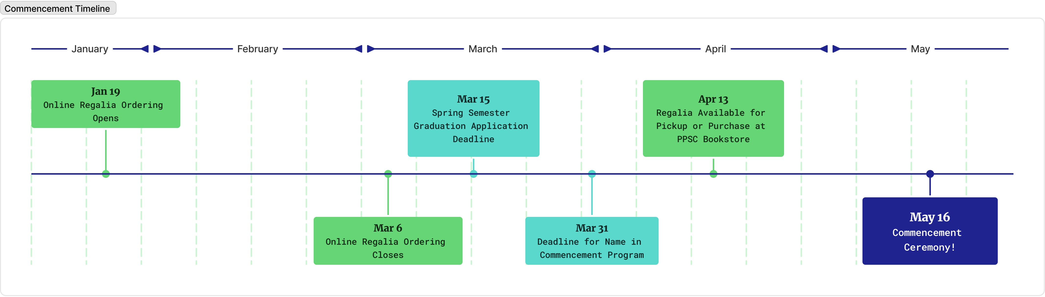
- January 26, 2026 – Online ordering opens
- March 6, 2026 – Online ordering closes
- April 13, 2026 – Online orders available for pickup starting this week. In-person
purchases available at Centennial Campus Bookstore.

Choosing your Package
For the 2026 Commencement Ceremony, you will choose your regalia package by the division or pathway that your program falls under. If you are unsure of your division or pathway, see the lists below. If you are earning credentials from more than one division, you may choose which regalia package you wish to wear.
Graduates earning a bachelor's degree will have a navy cap and gown. All other graduates will have a black cap and gown.
Technical and Professional Studies (TPS)
Tassel Color: Professor Plum
American Sign Language/Interpreter Preparation | Associates or Certificate
Architectural Engineer/Construction Management | Associates or Certificate
Automotive Service Technology | Associates
Automotive Collision Technology | Associates
Broadcasting and Electronic Media | Associates or Certificate
Building and Construction Technology | Associates or Certificate
Computer Aided Drafting | Associates or Certificate
Diesel Technology | Associates or Certificate
Heating, Refrigeration and Air Conditioning | Associates or Certificate
Industrial Mechatronics Maintenance Technology | Associates or Certificate
Interior Design | Associates or Certificate
Machining Technology | Associates or Certificate
Multimedia Graphic Design | Associates or Certificate
Robotics & Automation Systems Technology | Associates or Certificate
Welding | Associates or Certificate

Business, Technology, and Public Service (BTPS)
Tassel Color: Raspberry Berret

Accounting | Associates or Certificate
Business | Associates or Certificate
Computer Information Systems | Associates or Certificate
Computer Networking | Associates or Certificate
Computer Science | Associates
Criminal Justice | Associates or Certificate
Culinary Arts | Associates or Certificate
Cybersecurity | Bachelors, Associates or Certificate
Early Childhood Education | Associates or Certificate
Economics | Associates
Education | Associates
Emergency Management and Planning | Associates
Emergency Services Administration | Bachelors
Fire Science Technology | Associates or Certificate
Hospitality | Associates
Hospitality & Resort Management | Associates
Pikes Peak Regional Law Enforcement Academy | Certificate
Paralegal | Associates or Certificate
Social Work | Associates or Certificate

Arts, Humanities, and Social Sciences (AHSS)
Tassel Color: Scarlet Sunset
Anthropology | Associates
Art | Associates
Communication | Associates
Dance | Associates
English | Associates
English as Second Language | N/A
French | Associates
History | Associates
Humanities | Associates or Certificate
Journalism | Associates
Music | Associates
Philosophy | Associates
Photography | Associates or Certificate
Political Science | Associates
Professional Writing & Communication | Associates
Psychology | Associates
Sociology | Associates
Spanish | Associates
Theatre | Associates
World Languages | Associates

Science, Engineering and Math (SEM)
Tassel Color: Orange Oasis

Biology | Associates
Chemistry | Associates
Dietetics | Associates
Dietary Management | Associates
Engineering | Associates
Environmental Science | Associates
Geography | Associates
Geology | Associates
Health and Wellness | Associates or Certificate
Health, Wellness and Fitness | Associates or Certificate
Math | Associates
Medical Professionals | Associates
Outdoor Leadership | Associates
Physics | Associates
Public Health | Associates
Veterinary Assisting | Certificate
Veterinary Technology | Certificate
Zoo Keeping Technology | Associates or Certificate

Health Sciences (HS)
Tassel Color: Serenity at Sea

Advanced Paramedic Practitioner | Bachelors
Allied Health | Associates
American Heart Association Training Center | Certificate
Nursing | Associates
Nursing | Bachelors
Behavioral Health | Associates
Dental Assisting | Associates
Dental Hygiene | Associates
Emergency Medical Services | Bachelors or Certificate
Licensed Practical Nurse | Associates
Medical Assistant | Associates or Certificate
Medical Office Technology | Certificate
Nursing Assistant | Certificate
Pharmacy Technician | Certificate
Phlebotomy | Certificate
Physical Therapist Assistant | Associates
Practical Nursing | Certificate
Radiology Technology | Associates
Surgical Technology | Associates

General Studies (GS)
Tassel Color: Granny Smith

Associates degrees with NO designation | Associates

Size Guide
OAK HALL CAP & GOWN SIZE CHART

Height | Weight
4’9” – 4’11” | Up to 130 lbs.
5’ – 5’2” | Up to 150 lbs.
5’3” – 5’5” | Up to 170 lbs.
5’6” – 5’8” | Up to 250 lbs.
5’9” – 5’11” | Up to 275 lbs.
6’ – 6’2” | Up to 300 lbs.
6’ – 6’5” | Up to 325 lbs.
Plus 1* 4’9” – 5’5” | Over 200 lbs.
Plus 2* 5’6” – 5’11” | Over 275 lbs.
Plus 3* 6’ – 6’5” | Over 325 lbs.

*NOTE: The Plus size gown will comfortably ﬁt a bust/waist/hip measurement of 72". If you do not need this much width in the body of the gown, but your weight is slightly higher than the ranges listed above, order the next gown length, i.e., instead of 5'3-5' 5", order size 5 '6-5 '8".

Cords, Stoles and Medallions
For student clubs, organizations, and programs, contact your club or program advisors for information about cords and stoles.

Honor Cords are distributed during commencement check-in. Make sure to verify your cumulative GPA prior to Commencement check-in to ensure you receive the correct cord for your academic achievement:
- Graduating with highest honor, Summa Cum Laude - 4.0 cumulative GPA (Gold cord)
- Graduating with great honor, Magna Cum Laude - 3.75 – 3.99 cumulative GPA (Navy cord)
- Graduating with honor, Cum Laude - 3.5 - 3.749 cumulative GPA (Lime cord)

Current PPSC cords and stoles available include:
- Phi Theta Kappa (Can be purchased from Phi Theta Kappa)
- Military Recognition (Medallions provided by MVP)
- LGBTQIA2+ Recognition (Provided by PPSC)
- High School Programs (Provided by PPSC)
- COSI (Provided by COSI)
- Promise Programs (Provided by Promise Programs)
- Work-Study (Provided by Career Services or PPSC)
- Military and Veterans Work-Study (Provided by PPSC)
- Student Ambassadors (Provided by Enrollment Department)
- Student Government Association (Provided by PPSC)
You may also purchase any other stoles you wish to wear during the ceremony via the online ordering site, the bookstore, or your vendor of choice.

Links and Resources
Commencement Frequently Asked Questions How to Wear Graduation Regalia
Still have questions? Please reach out to commencement@pikespeak.edu.

