1. Navigate to <https://www.myclinicalexchange.com/MainPage.aspx>  
2. Click on the Student Login option.  
3. To initially set up your password please select the "Forgot Password" button.  
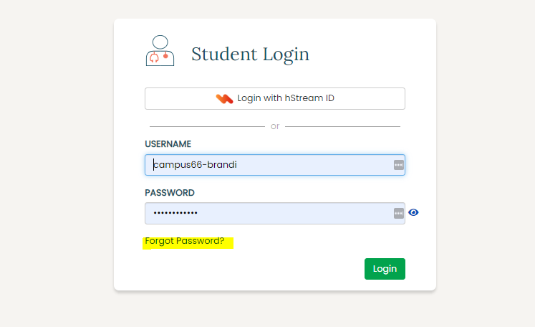  
4. You will then enter in your registered email address as your login ID and enter in the security code and hit continue.  
5. You will then select the email to send a password reset link to.  
6. Check the inbox of your registered email address and locate the password reset email from [donotreply@myclinicalexchange.com](mailto:donotreply@myclinicalexchange.com). You will click on the link in the email to open the page where you will set your password up.  
7. After your password is set you can click continue to navigate back to the login page.  
8. From the login page you will enter in your registered email address as the login id and the new password you created.